Naan mudhalvan project

India’s Agricultural Crop Production Analysis (1997-2021)

College : Arignar anna government arts college for women, walajapet,

Ranipet district -632 513

Department of mathematics

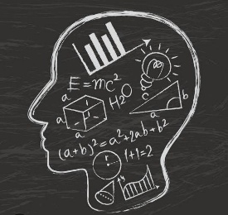

**Topic India’s Agricultural Crop Production Analysis (1997-2021)**

Submitted by

Team leader: Kanchana P

Team members:

1. Kanchana P
2. Jagadeeshwari K
3. Jayasri S
4. Jothilakshmi S

**Introduction**

Overview

According to The World Bank, India is a global agricultural powerhouse. It is the world's largest producer of milk, pulses, and spices, and has the world's largest cattle herd (buffaloes), as well as the largest area under wheat, rice and cotton. It is the second largest producer of rice, wheat, cotton, sugarcane, farmed fish, sheep & goat meat, fruit, vegetables and tea. While agriculture’s share in India’s economy has progressively declined to less than 15% due to the high growth rates of the industrial and services sectors, the sector’s importance in India’s economic and social fabric goes well beyond this indicator.

Objective

Let us analyze the Indian Agriculture crop production for the data collected from 1997 to 2022. Let us ask interesting questions on existing data, get production and area statistics and understand more on the Indian Agriculture history for crop production.

Purpose

Agricultural analysis is a very important aspects to crop growing. To increase quality and yields, it is crucial to Understand the current nutrient level of the soil, seasonal changes to be able to ascertain which areas require improvement.

**Problem definition and design thinking:**

Empathy map:

Empathy maps help identify patterns and themes that are important to your project, enabling you to understand the real problem to be solved.

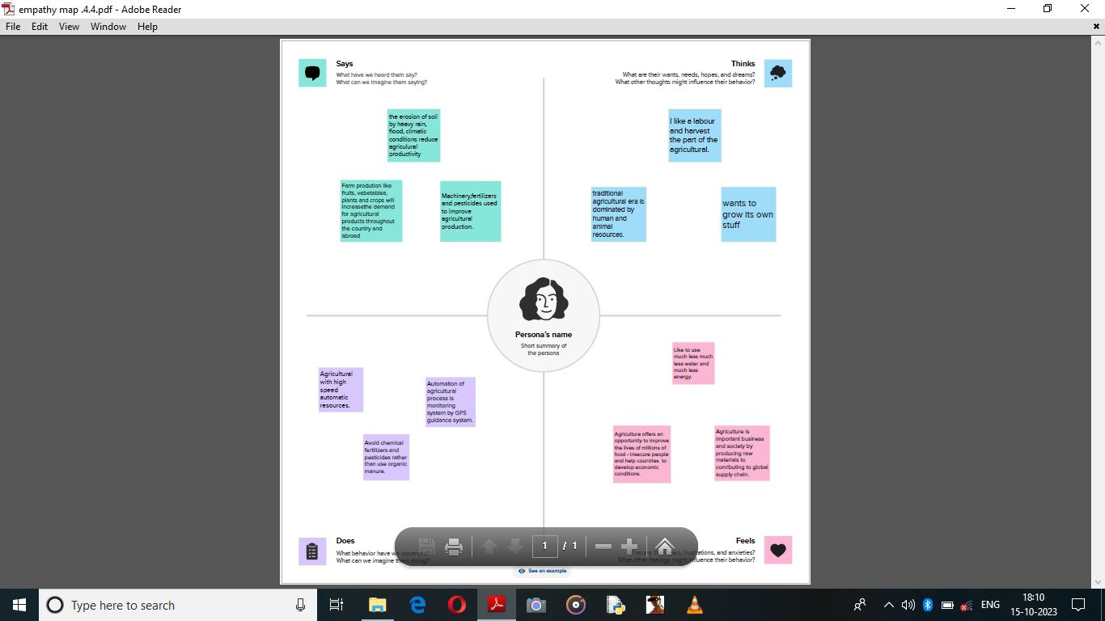

Ideation and brainstorming map:

An ideation mind map is a visual diagram that helps you organize and structure your thoughts and ideas. It works by creating a central idea or concept, and then branching out into smaller, related ideas that connect to the central idea.

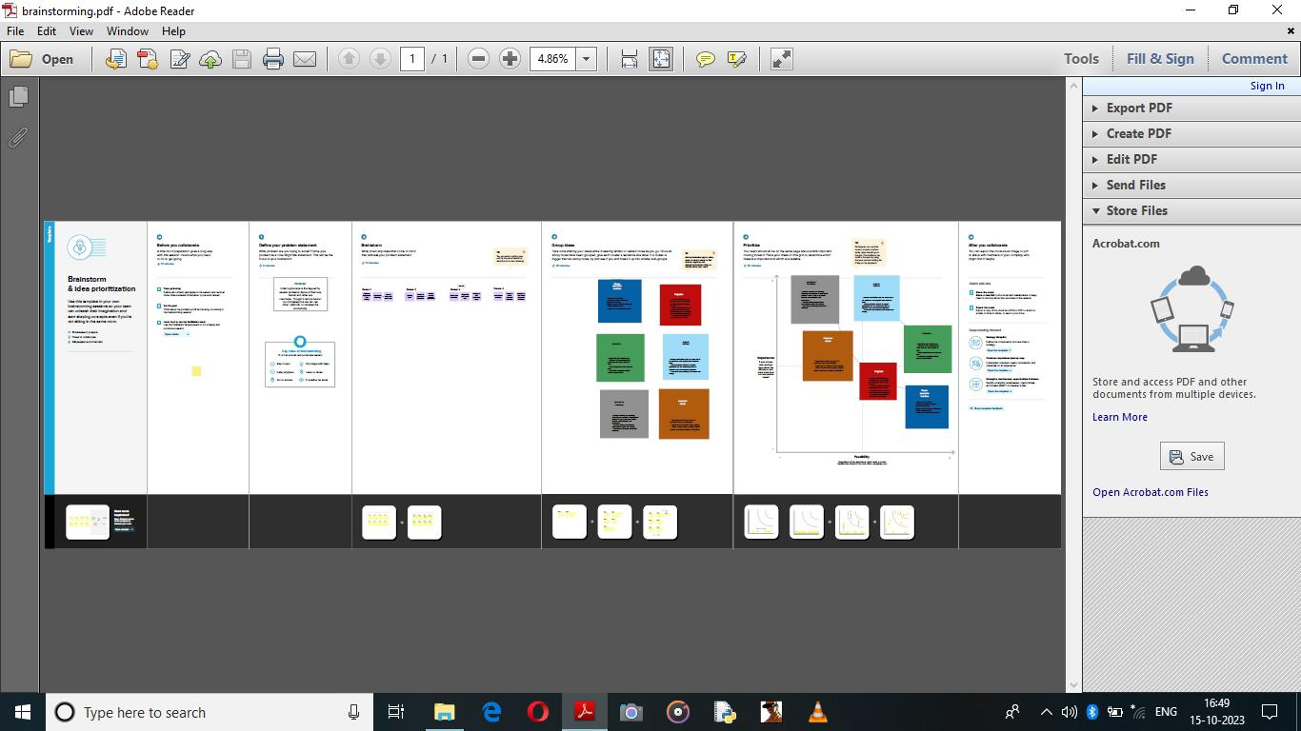

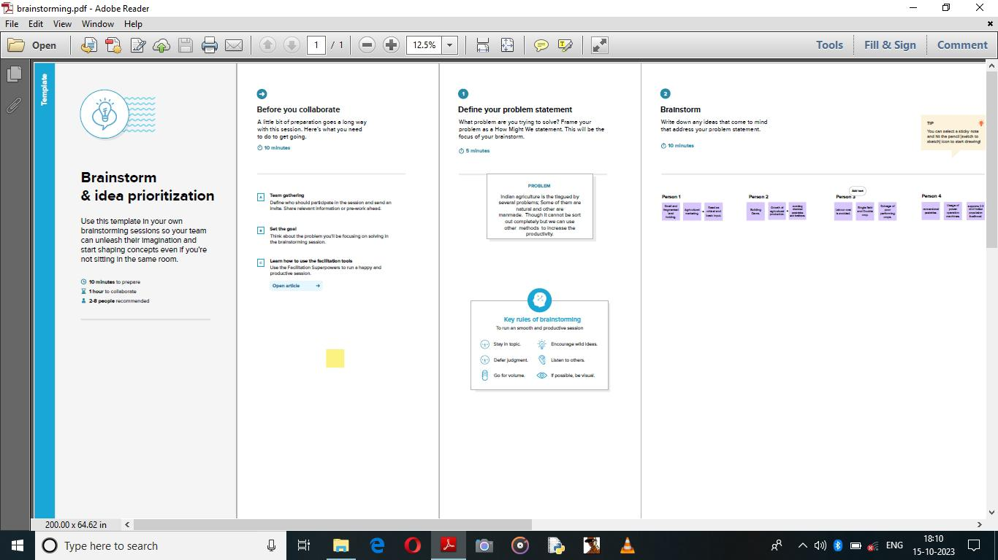

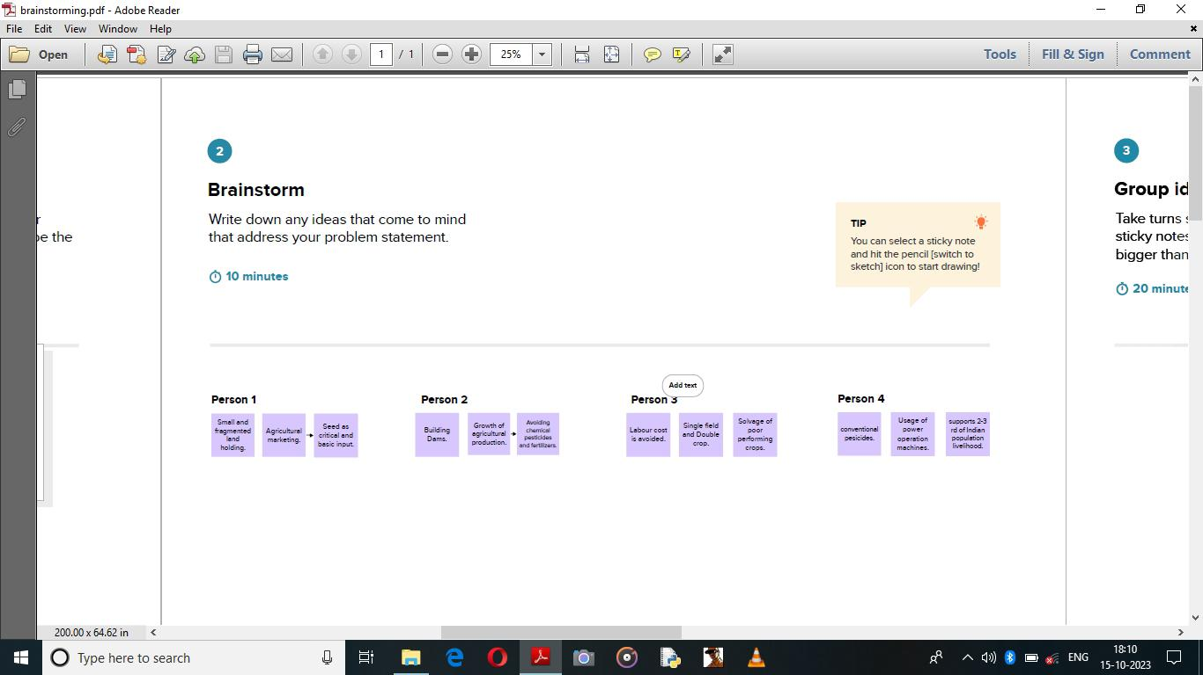





Source of Data

Data is open available on Kaggle which is made available Ministry of Agriculture and Farmers Welfare of India

<https://www.kaggle.com/datasets/pyatakov/india-agriculture-crop-production>

**Worksheets**

1. Statewise agricultural land

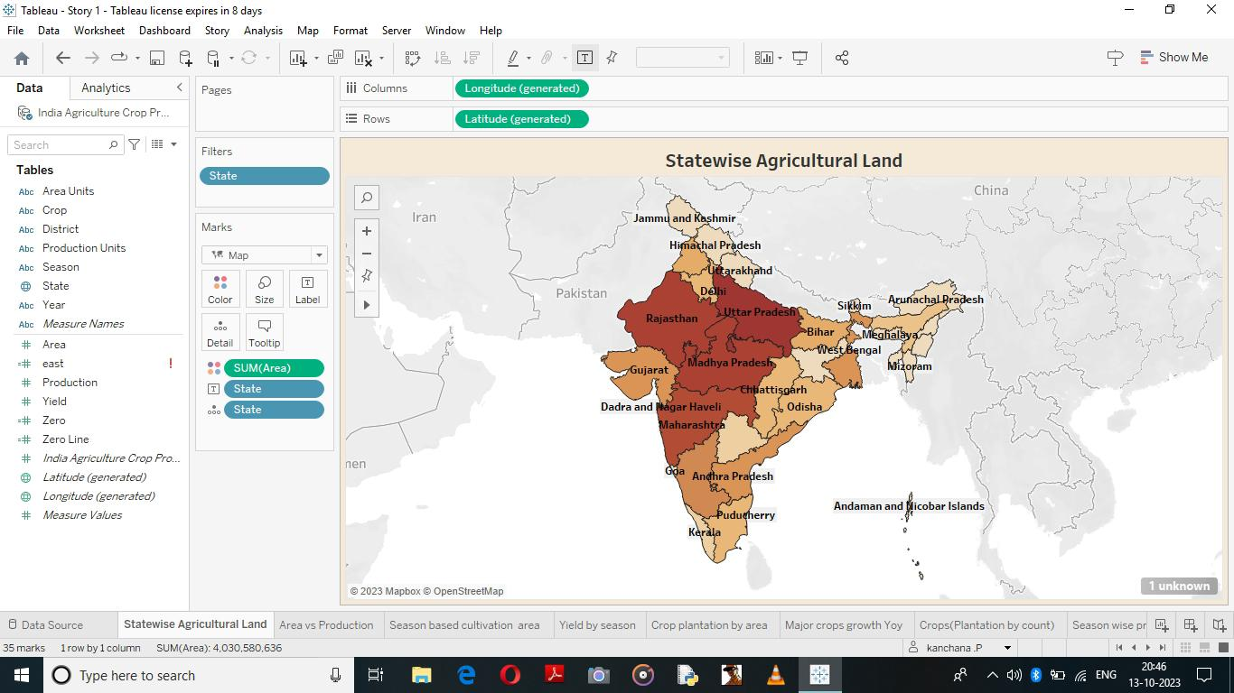

2)Area vs Production

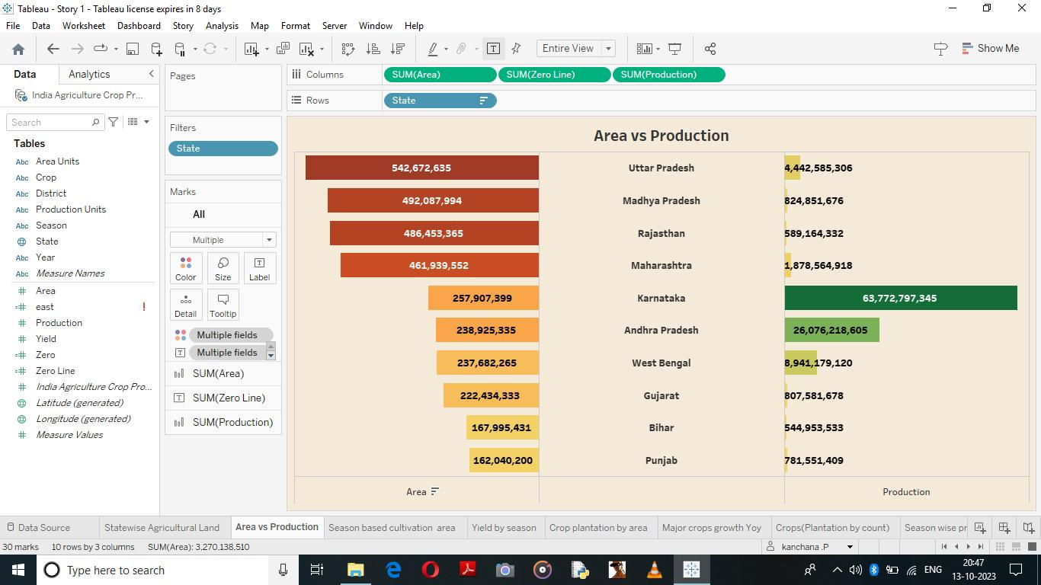

3) 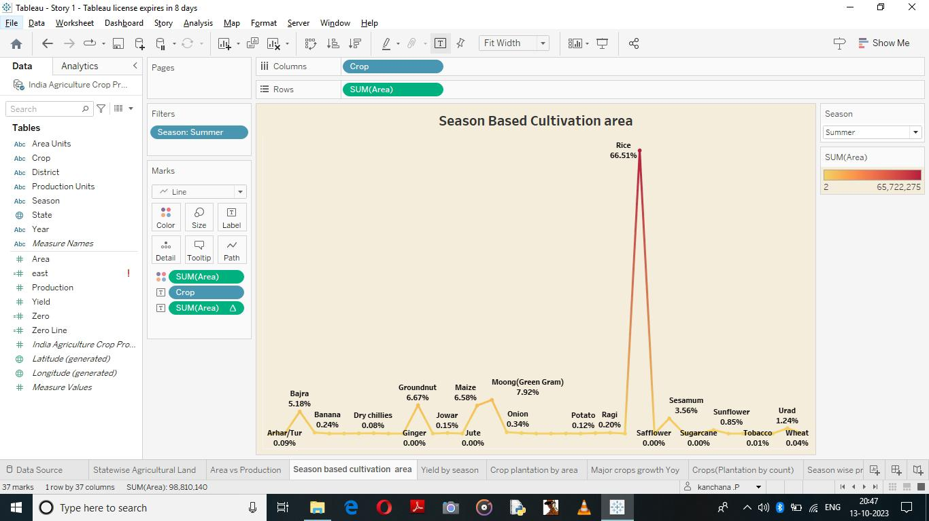Season based cultivation

4)Yield by season

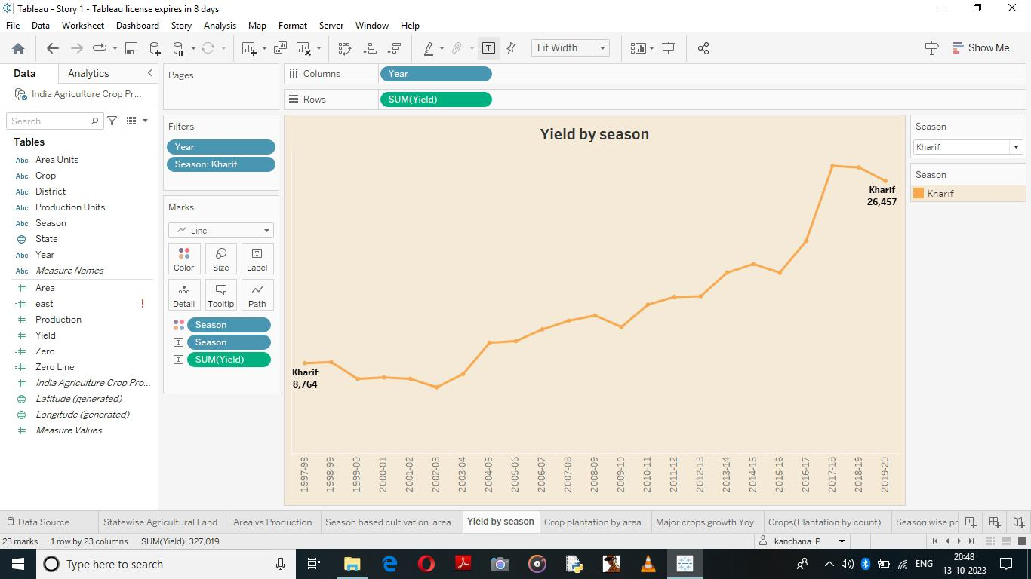

5)Crop plantation by area

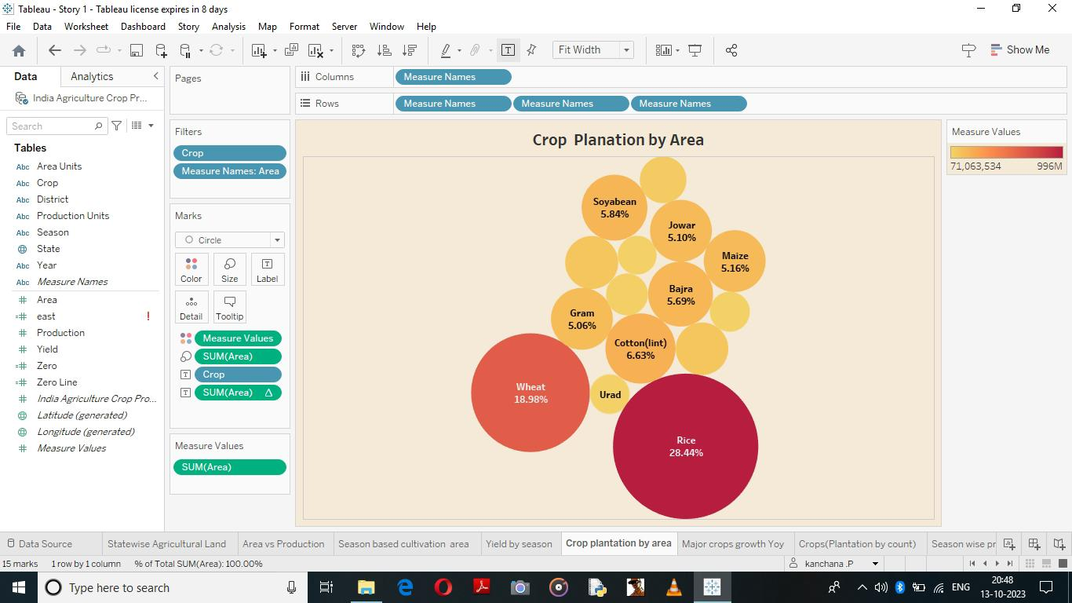

6)Major crops grown Yoy

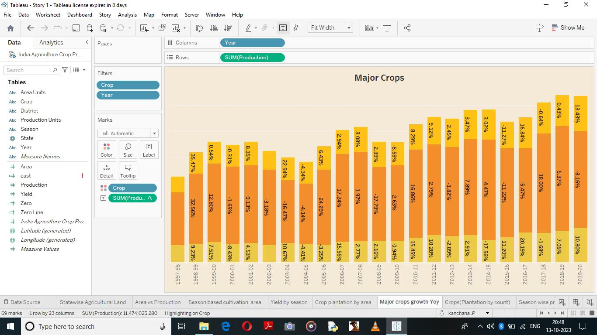

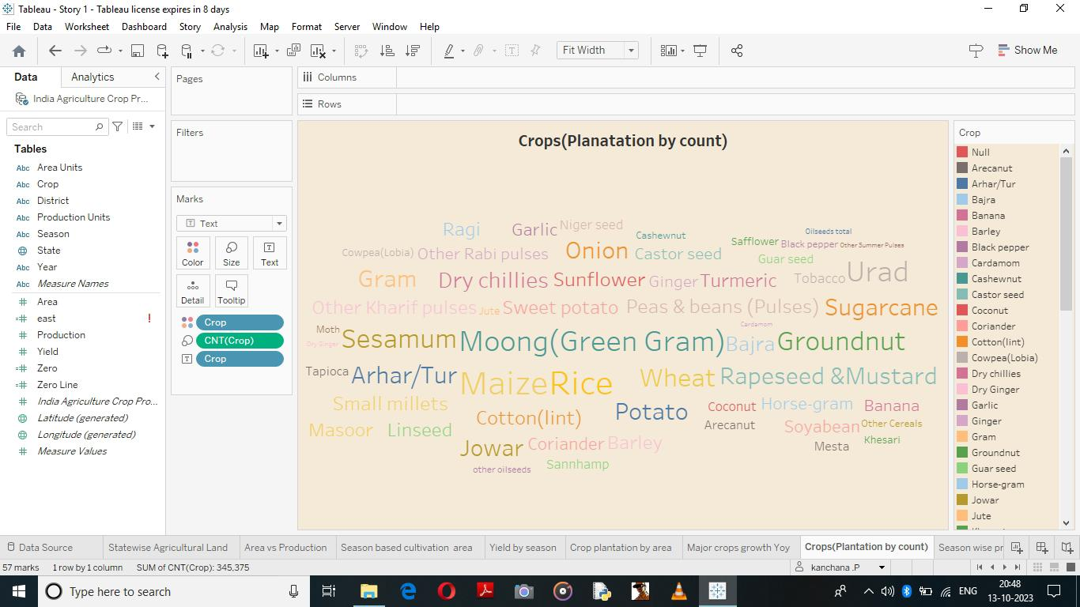7)Crops

8) Season wise production

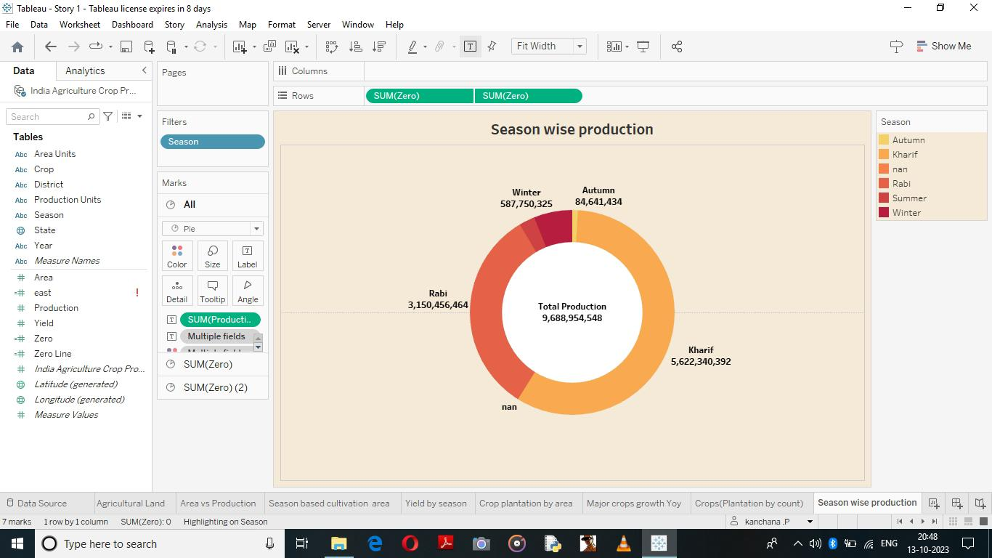

9)kpi’s



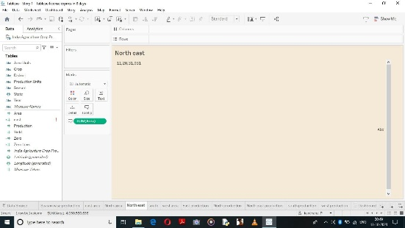

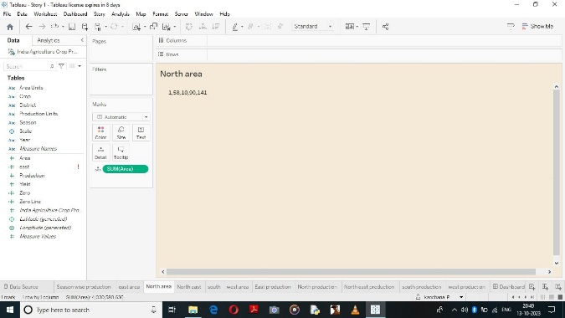



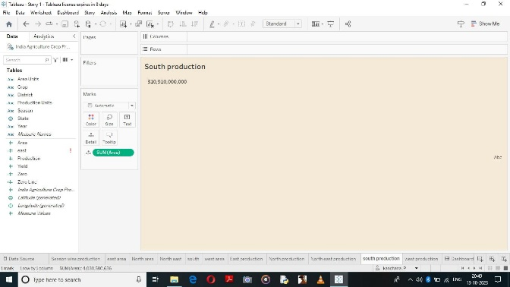

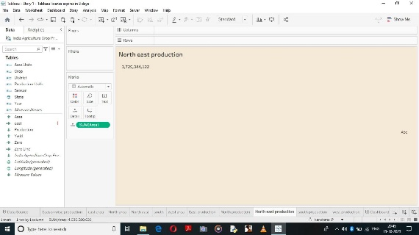

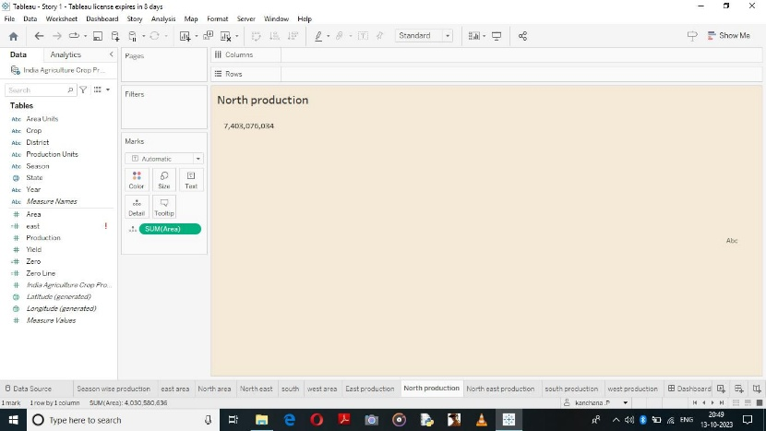

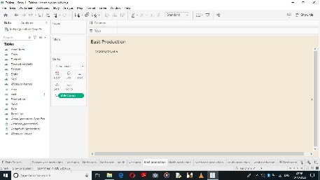

Dashboard1

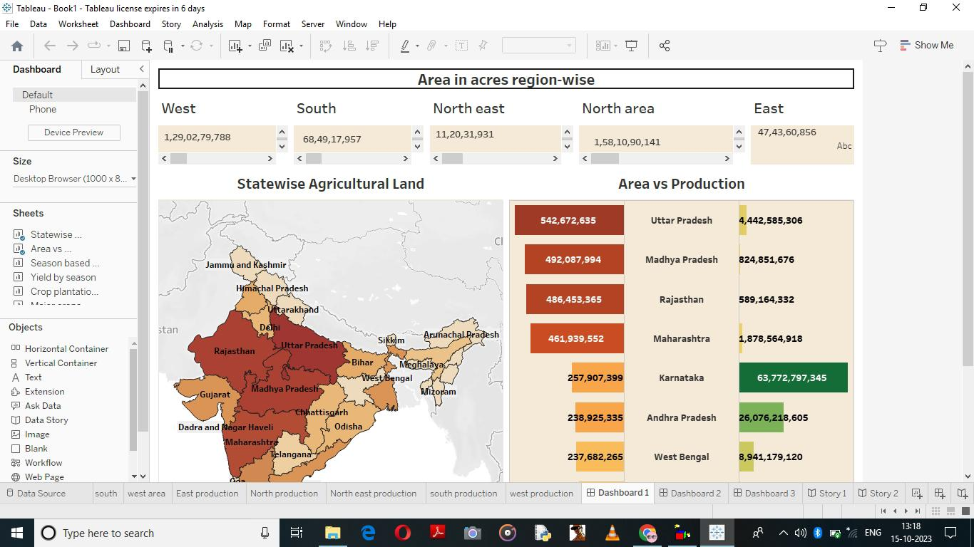

Dashboard 2

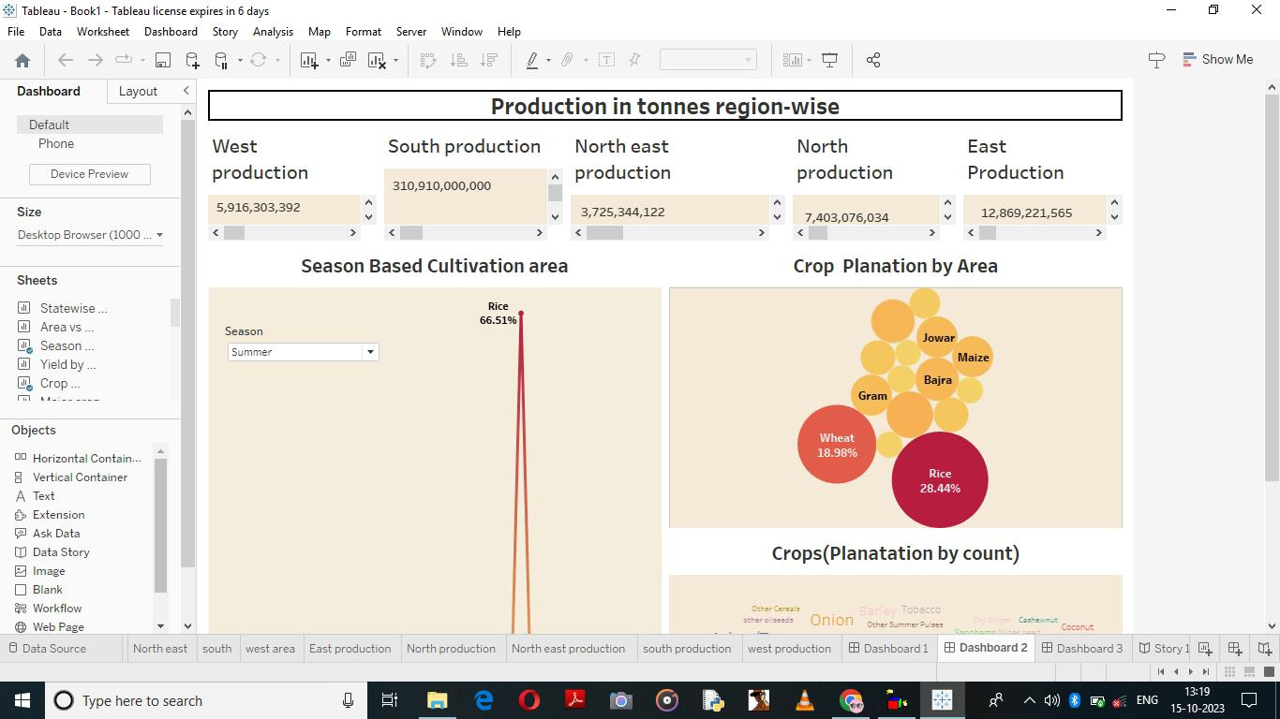

Dashboard 3

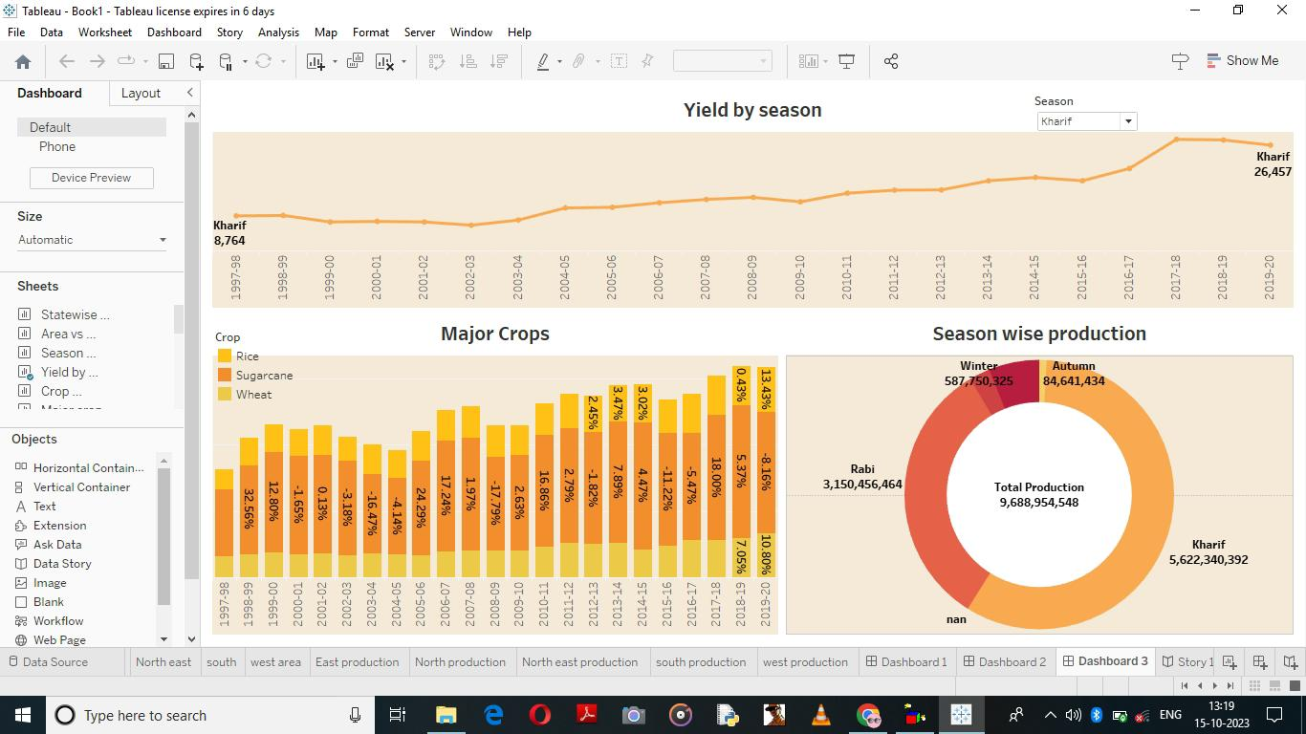

Story 1

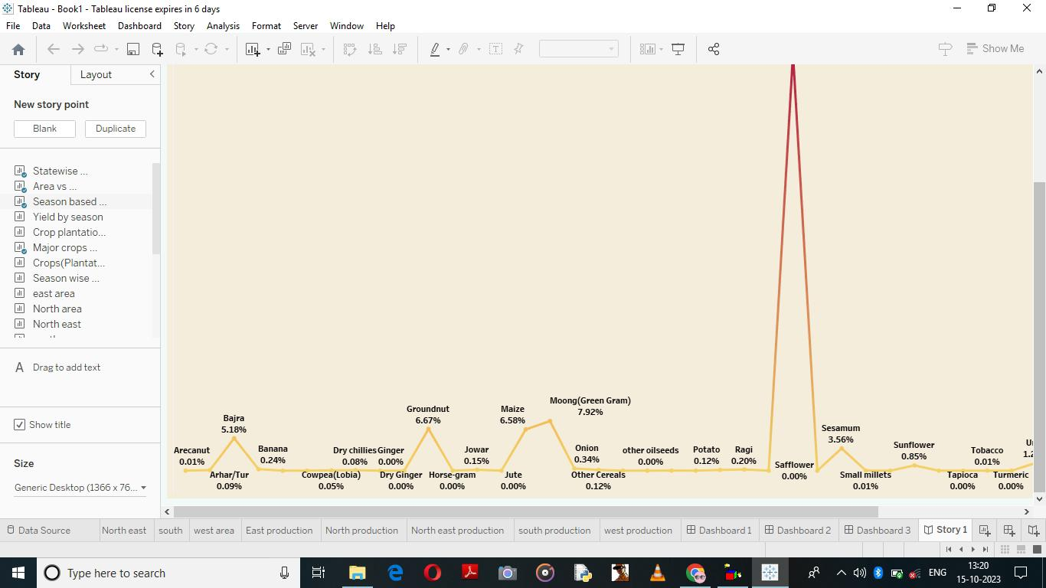

Story 2

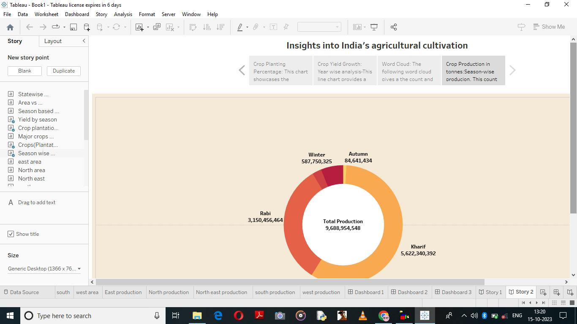

**Advantages and disadvantages**

Agriculture is an important part of economic management. In recent years, due to the popularization of the Internet, the adjustment of agricultural industry structure and the information management of agricultural industry have been accelerated. The wide application of information technology in rural economic management can effectively promote the development of rural economy. Because the development of my country’s agricultural information industry started late, and its application is relatively late. On this basis, this article studies the advantages and disadvantages of agricultural economic management information, such as modern production factors and agricultural economic information management by means of agricultural data collection. Taking the agricultural economic management informationization as the experimental group and traditional agricultural economic management as the control group, the application research is carried out. Through the use case test of the agricultural informationization platform data collection system, it is shown that information technology can effectively improve the efficiency of agricultural production. Experimental results show that information technology can effectively make up for the lack of economic information management in agricultural production and life. In addition, the government should increase capital investment in personnel training to promote agricultural economic management information**.**

**Applications**

Exploratory data analysis

Let us get into the details with exploration of data to answer various questions. Let us place those general questions we want to get an answer from the data. Let us get some basic details like crops which are their in our records, states and districts we have in our records, etc.

Dealing with various units of production

We can observe a column named Production units which is a mesurement of crop production. We need to standardize the units to one specific unit to do proper measurement.

**Conclusion**

Enhancing agricultural productivity, competitiveness, and rural growth

Promoting new technologies and reforming agricultural research and extension: Major reform and strengthening of India’s agricultural research and extension systems is one of the most important needs for agricultural growth. These services have declined over time due to chronic underfunding of infrastructure and operations, no replacement of aging researchers or broad access to state-of-the-art technologies. Research now has little to provide beyond the time-worn packages of the past. Public extension services are struggling and offer little new knowledge to farmers. There is too little connection between research and extension, or between these services and the private sector.

Improving Water Resources and Irrigation/Drainage Management: Agriculture is India’s largest user of water. However, increasing competition for water between industry, domestic use and agriculture has highlighted the need to plan and manage water on a river basin and multi-sectoral basis. As urban and other demands multiply, less water is likely to be available for irrigation. Ways to radically enhance the productivity of irrigation (“more crop per drop”) need to be found. Piped conveyance, better on-farm management of water, and use of more efficient delivery mechanisms such as drip irrigation are among the actions that could be taken. There is also a need to manage as opposed to exploit the use of groundwater. Incentives to pump less water such as levying electricity charges or community monitoring of use have not yet succeeded beyond sporadic initiatives. Other key priorities include: (i) modernizing Irrigation and Drainage Departments to integrate the participation of farmers and other agencies in managing irrigation water; (ii) improving cost recovery; (iii) rationalizing public expenditures, with priority to completing schemes with the highest returns; and (iv) allocating sufficient resources for operations and maintenance for the sustainability of investments.

Facilitating agricultural diversification to higher-value commodities: Encouraging farmers todiversify to higher value commodities will be a significant factor for higher agricultural growth, particularly in rain-fed areas where poverty is high. Moreover, considerable potential exists for expanding agro-processing and building competitive value chains from producers to urban centers and export markets. While diversification initiatives should be left to farmers and entrepreneurs, the Government can, first and foremost, liberalize constraints to marketing, transport, export and processing. It can also play a small regulatory role, taking due care that this does not become an impediment.

Promoting high growth commodities: Some agricultural sub-sectors have particularly high potential for expansion, notably dairy.

**Future scope**

Having found in more than 21 K records, Rice seems to be the most popular choice for farmers in India, followed by Mazie and Moong.

From above output we can conclude that, Uttar Pradesh, Kerala, Tamil Nadu, Karnataka, and Maharashtra are the top 5 states with highest total crop production in total for years from 1997 to 2021.

From the above output we can see that West Bengal, Uttar Pradesh, Punjab, Andhra Pradesh and Odisha are the top 5 states with max rice production

Year 2018-19, 2017-18, 2011-12, 2014-25, 2013-14 respectively had maximum crop production out of all years in the records

From the above output we can see that 1997-98 was the year with least production. This is possible due to lack of our capabilities to record the production of crops across Indi